Steps to install VirtualBox in CentOS 7
Step 1: Change baseurls in vi/etc/yum.repos.d/Centos-Base.repo
Comment the exiting mirrorlists
baseurl=http://vault.centos.org/7.9.2009/os/$basearch
baseurl=http://vault.centos.org/7.9.2009/updates/$basearch
baseurl=http://vault.centos.org/7.9.2009/extrass/$basearch
1. Update YUM repositories:
sudo yum update
2. Use the following command to install the kernel and necessary tools:
sudo yum install –y patch gcc kernel-headers kernel-devel make perl wget
Wait for the installation to finish.
3. Reboot the system to start using the new kernel:
sudo reboot
Step 2: Download VirtualBox Repository
The official Oracle's VirtualBox repository contains the latest versions of VirtualBox binaries available for download. To download the VirtualBox repository, enter the following wget command:
sudo wget http://download.virtualbox.org/virtualbox/rpm/el/virtualbox.repo -P /etc/yum.repos.d
edit the below file (at path vi /etc/yum.repos.d)
[virtualbox]
name=Oracle Linux / RHEL / CentOS-$releasever / $basearch - VirtualBox
baseurl=http://download.virtualbox.org/virtualbox/rpm/el/$releasever/$basearch
enabled=1
gpgcheck=1
repo_gpgcheck=1
gpgkey=https://www.virtualbox.org/download/oracle_vbox_2016.asc
Edited file should look like below
[virtualbox]
name=Oracle Linux / RHEL / CentOS-$releasever / $basearch - VirtualBox
baseurl=http://download.virtualbox.org/virtualbox/rpm/el/7/x86_64
enabled=1
gpgcheck=1
repo_gpgcheck=1
gpgkey=https://www.virtualbox.org/download/oracle_vbox_2016.asc

Step 3 : Install VirtualBox
sudo yum install VirtualBox-7.0
Step 4 : Check the status of the VirtualBox Linux kernel module service:
sudo systemctl status vboxdrv
Step 5: Start VirtualBox
VirtualBox
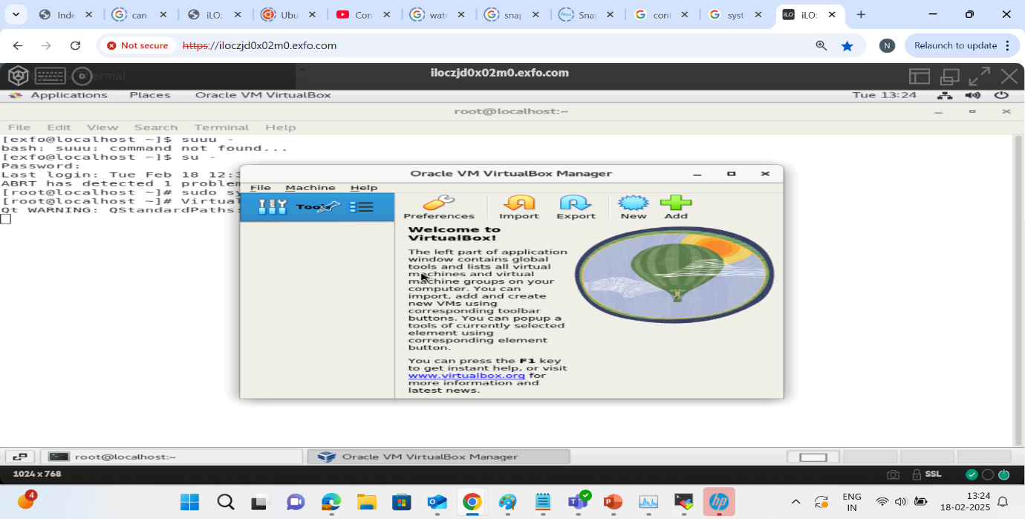
Steps to create a VM in VirtualBox
- Click on New
- Give the path of ISO click Next
- Configure username and password click Next
- Provide the Partition for the Hard-disk click Next
- Click on Finish

Reference link: https://phoenixnap.com/kb/virtualbox-centos

